Jenkins task-02

1.Configure 2 slave machines in Jenkins master.
Prerequisites: Install Jenkins on ec2 machine
And also install git.
In slaves we can install only java.
Step -1 :create a ssh-keygen in slave-01.
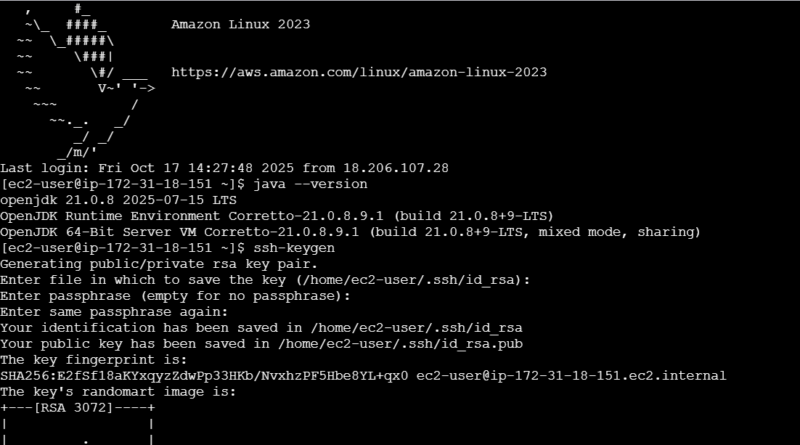
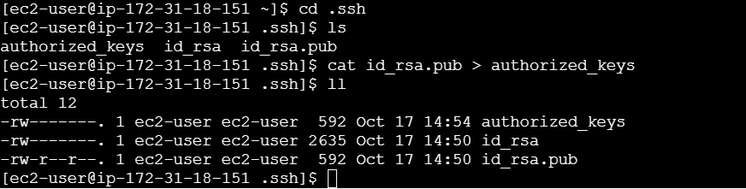
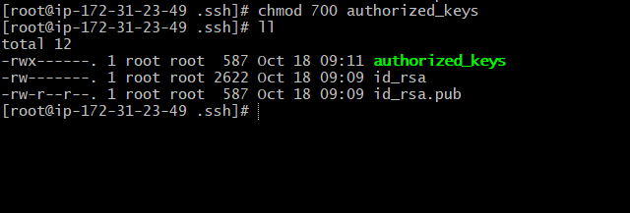
Step-2 : Go to master machine
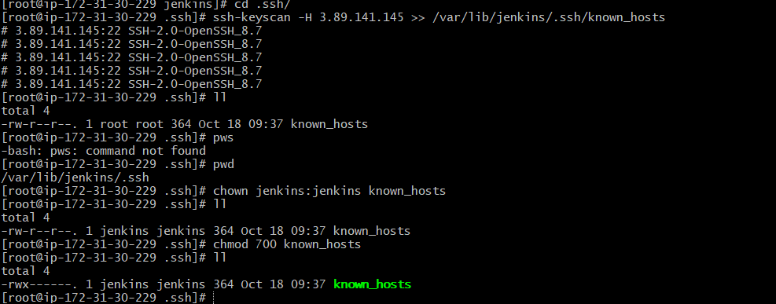
Step-3 : steps to be done on Jenkins GUI
Go to manage Jenkinsnodesclick on new nodecreate a new node create.
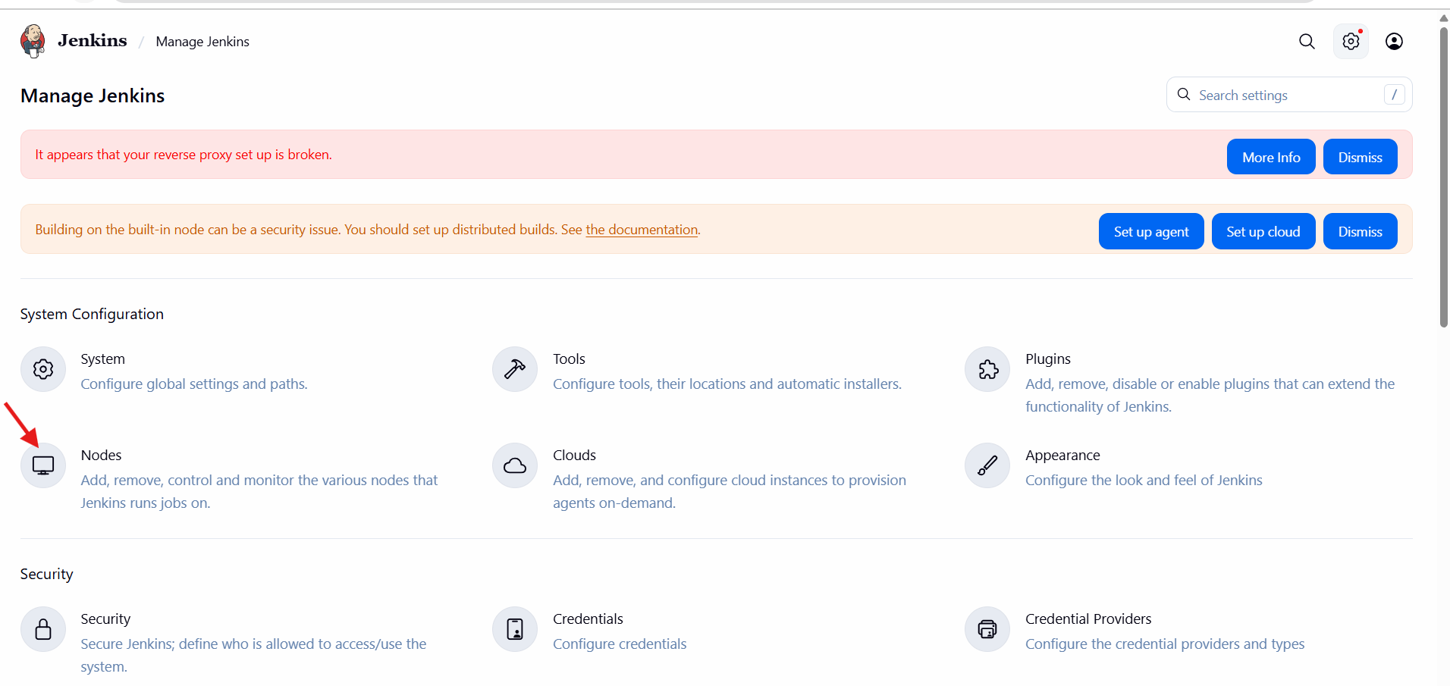
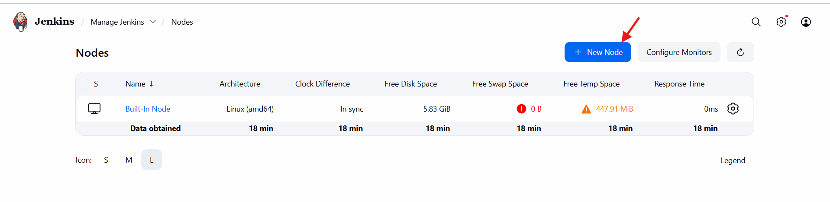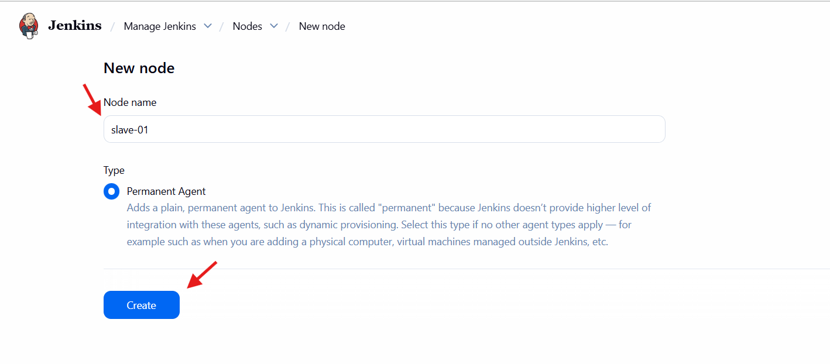
Node create a namedescriptionremote root directorylabelshost(slave-01 host ip) add credentials.
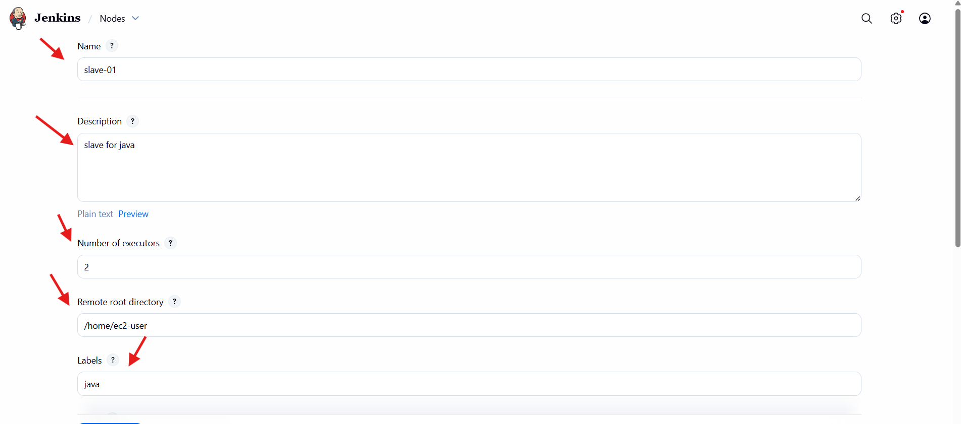
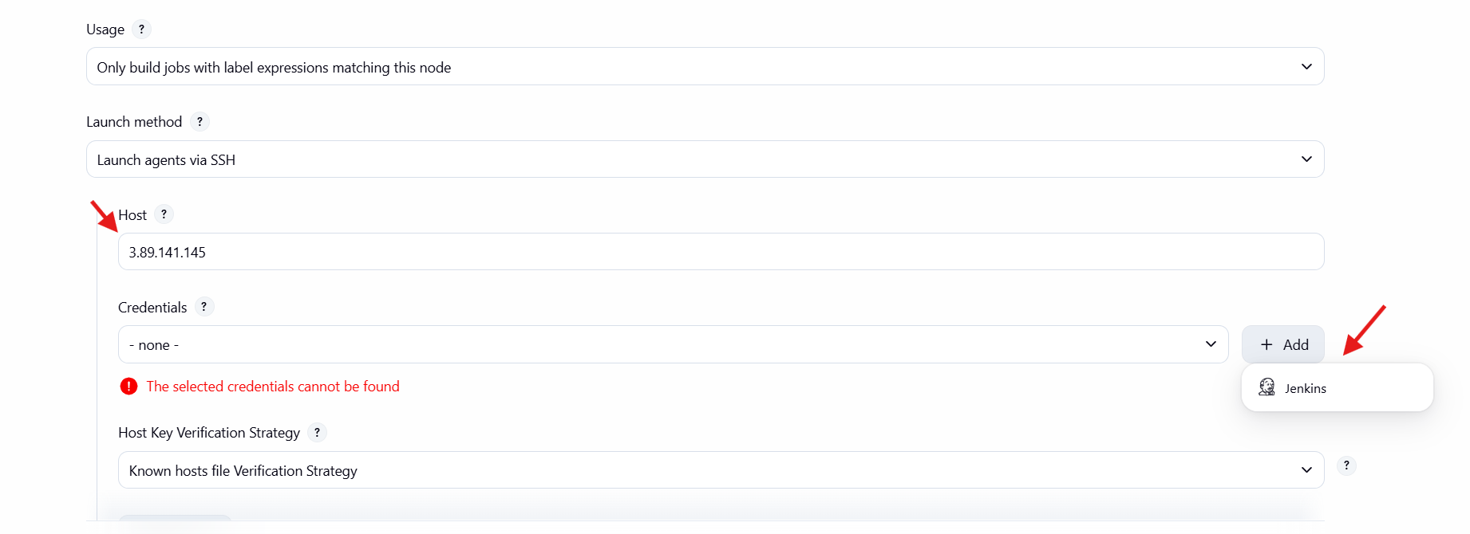
Select global credentials ssh username with private keyiddescription.
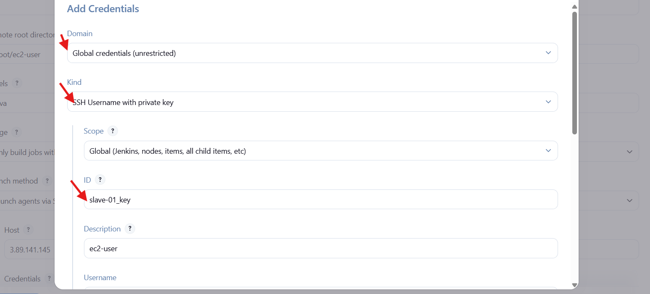
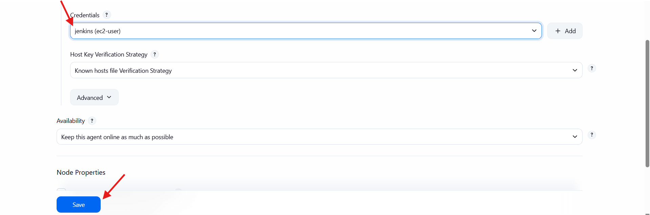
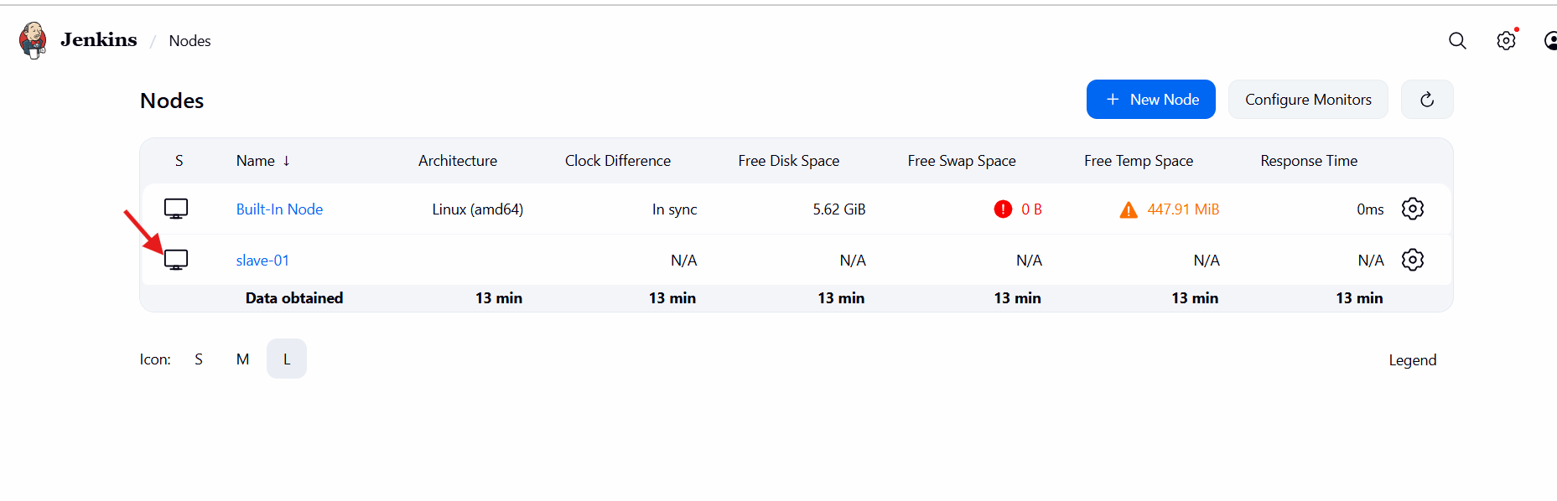
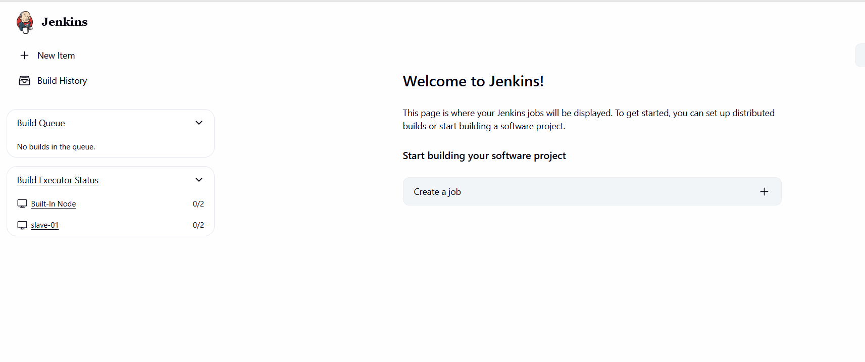
Same process as repeated for slave-02.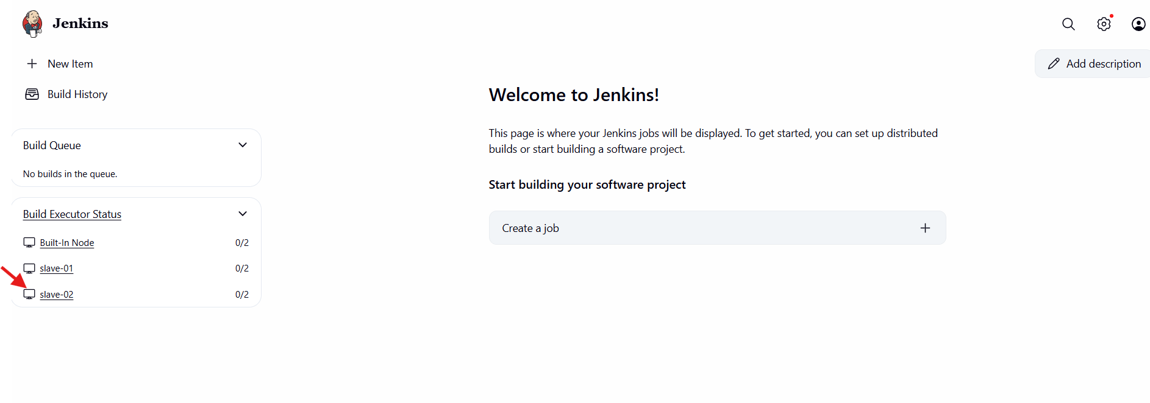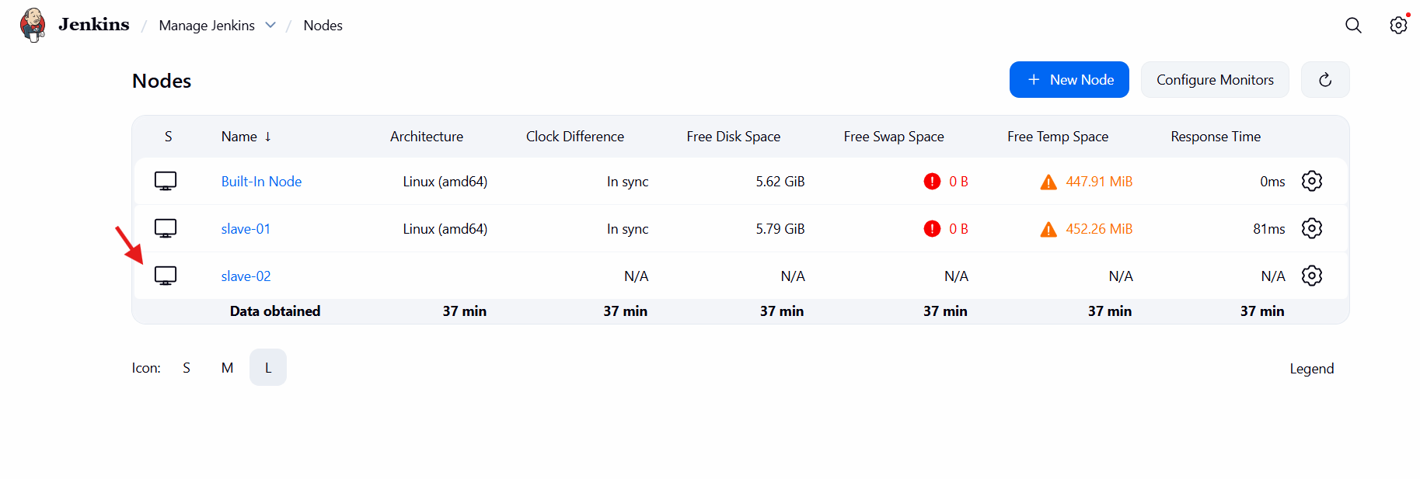
2.Configure webhooks to Jenkins job.
Webhooks-webhooks will help us to trigger our jobs whenever there is a change in source code.
Go to githubsettingswebhooksadd webhook.
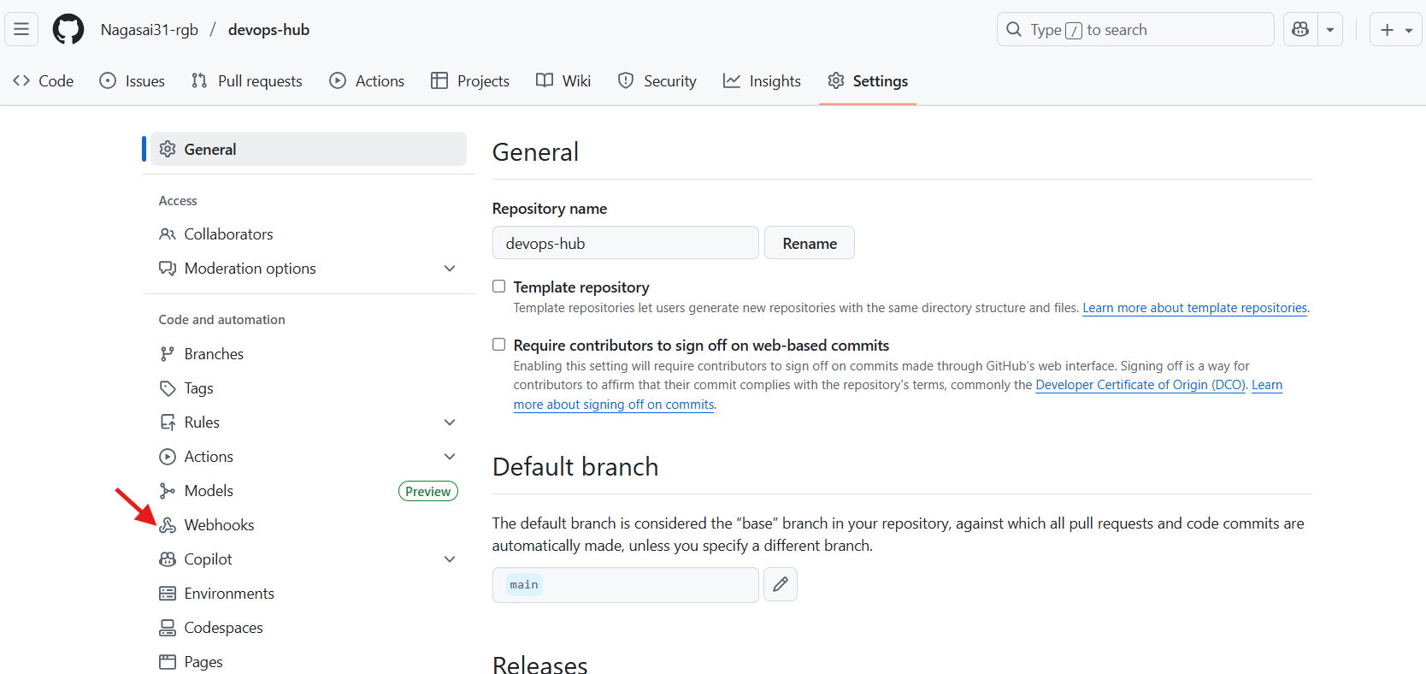

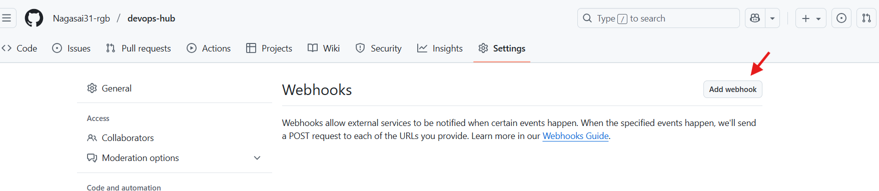
We can add the payload url(https:Jenkins url/github/webhook/) and select the events and click on save.
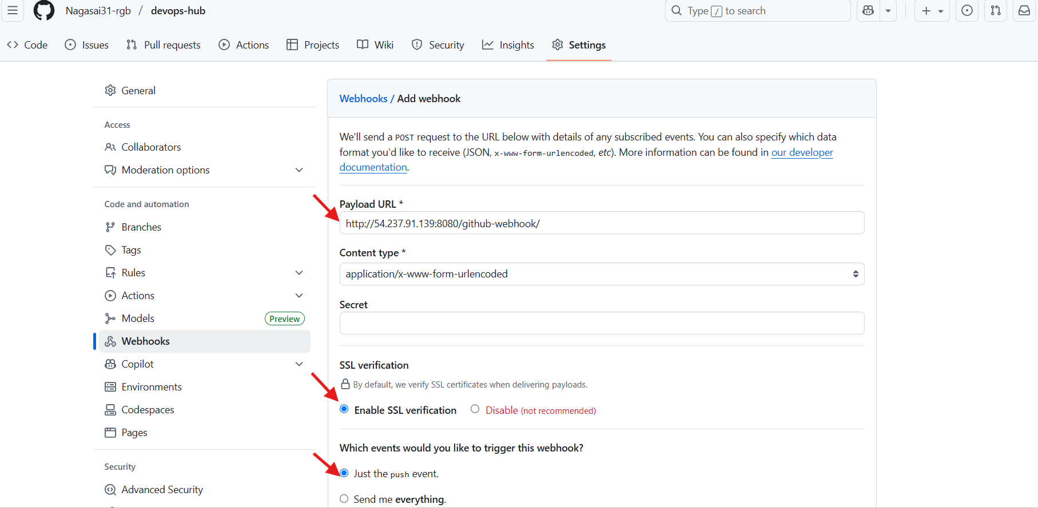
It will send a text message to Jenkins. After it is verified we can see the results.
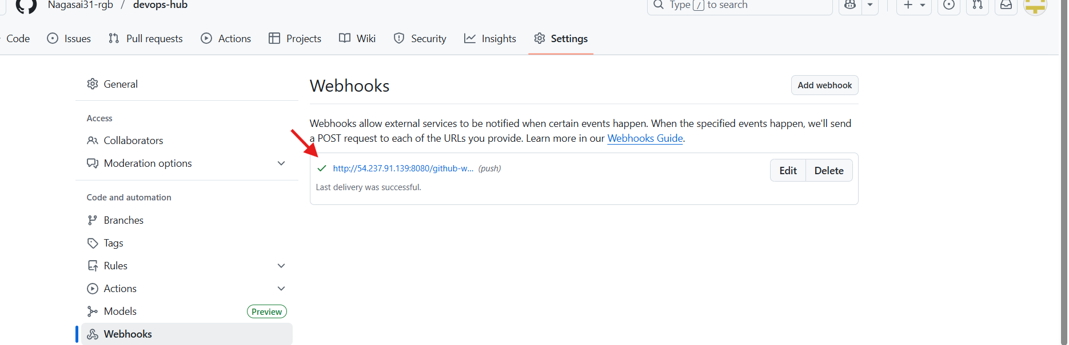
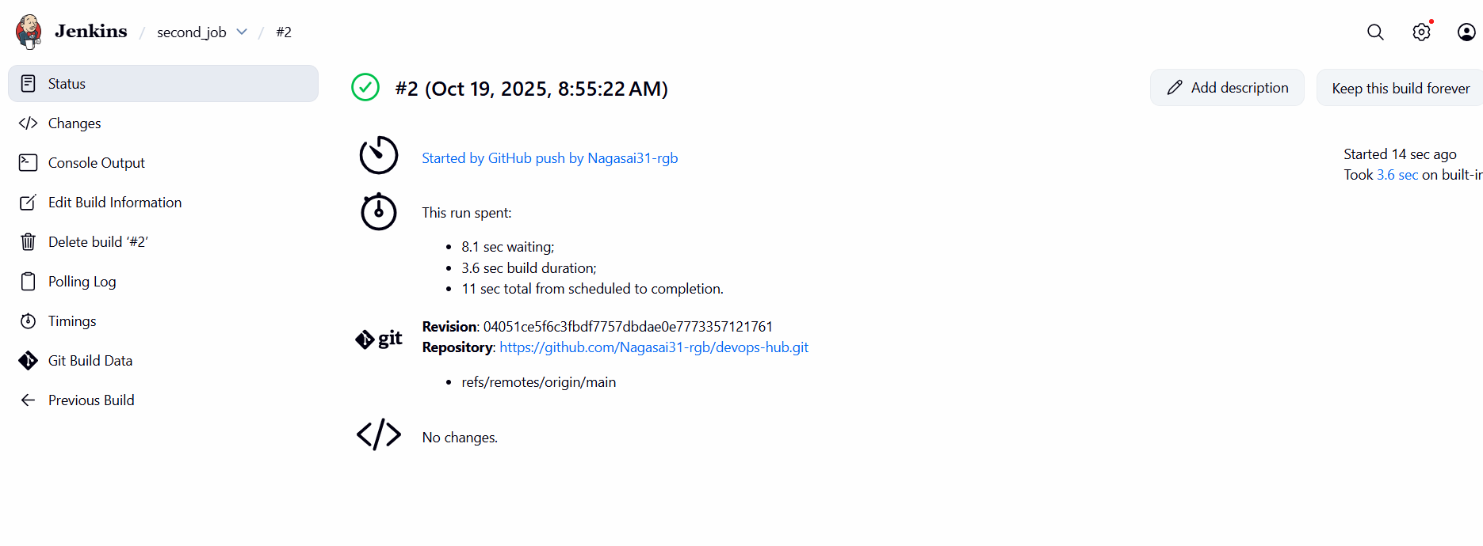

3.Configure poll scm and build periodical options in Jenkins job.
Poll scm: If there is any change in the source code the pollscm will get trigger.
Build periodical: If there is change or no change In the source code it should be trigger based upon timings.
Go to Jenkinsmake itemselect a free style projecttriggersselect pollscmschedule save.
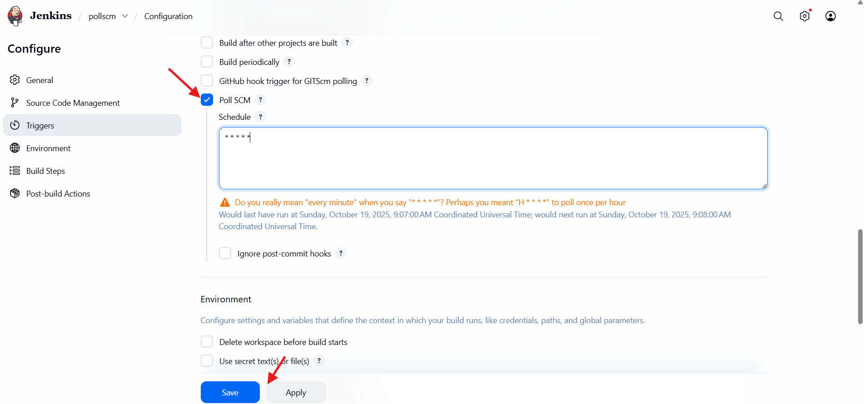
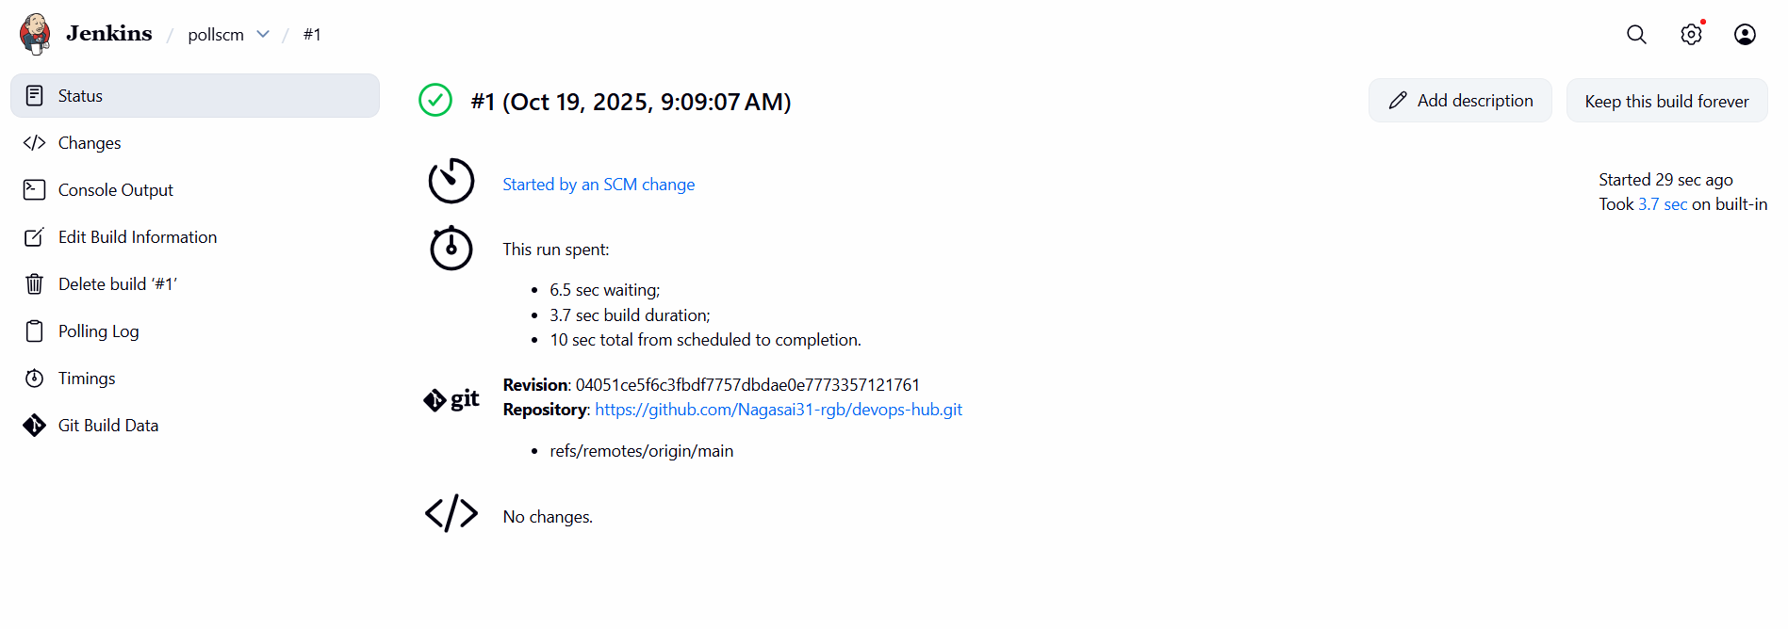
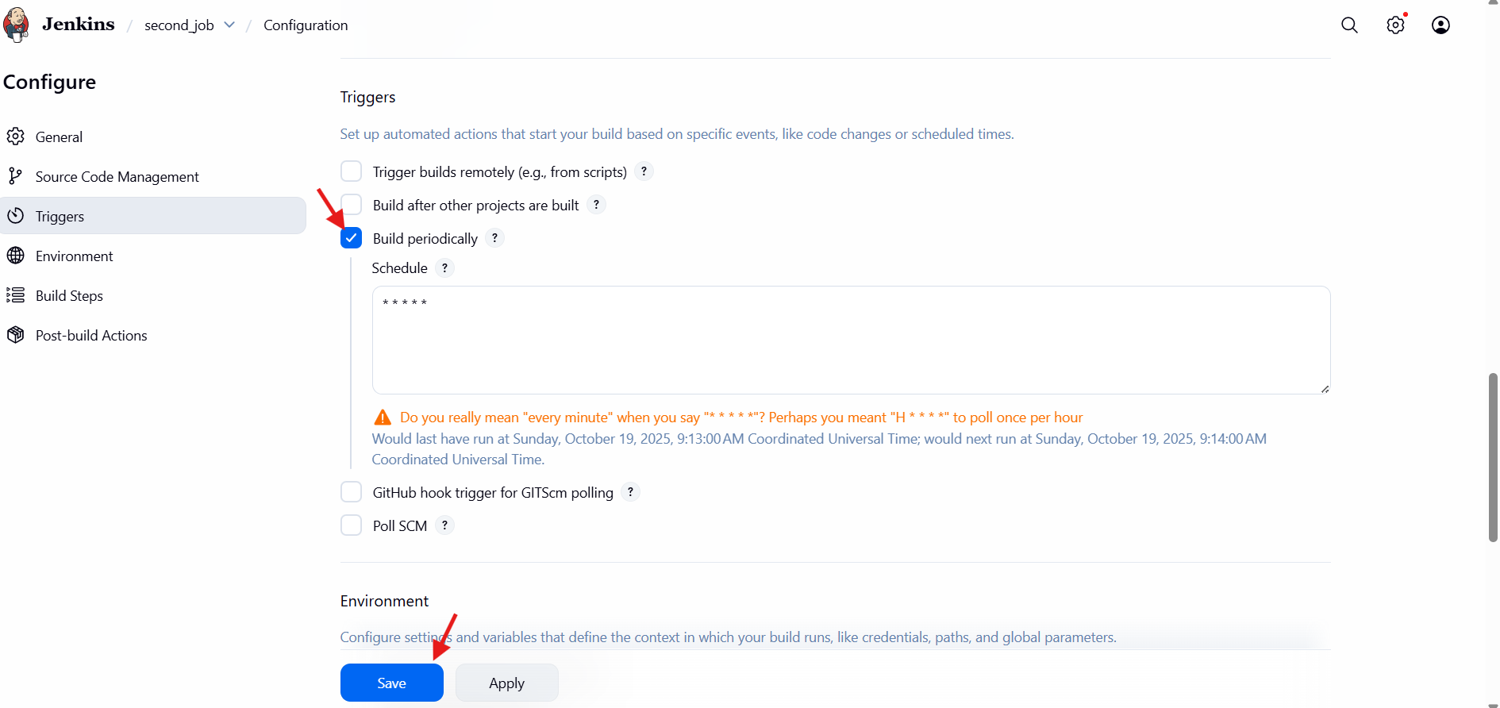
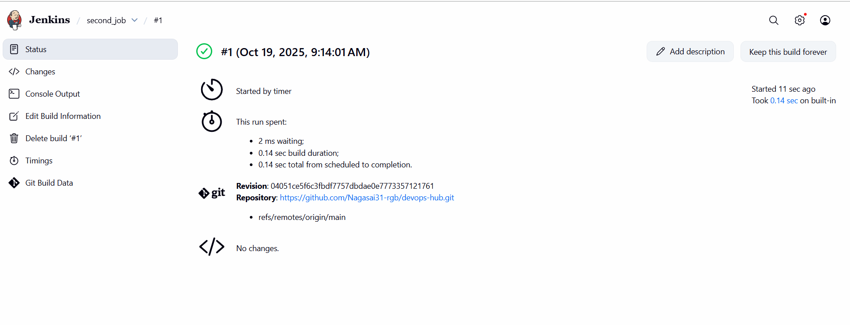

4.Take backup of Jenkins server by using bash script.
Go to master machine and create a bash script.
Vi Jenkins_backup.sh
#!/bin/bash
JENKINS_HOME="/var/lib/jenkins" # Jenkins home directory
BACKUP_DIR="/backup/jenkins" # Directory to store backups
DATE=$(date +%Y%m%d_%H%M%S) # Timestamp for the backup file
# Create backup directory if it doesn't exist
mkdir -p "$BACKUP_DIR"
# Create a compressed backup of Jenkins home
tar -czf "$BACKUP_DIR/jenkins_backup_$DATE.tar.gz" -C "$JENKINS_HOME" .
chmod 777 jenkins_backup.sh
./jenkins_backup.sh.

echo "Jenkins backup completed successfully: $BACKUP_DIR/jenkins_backup_$DATE.tar.gz"
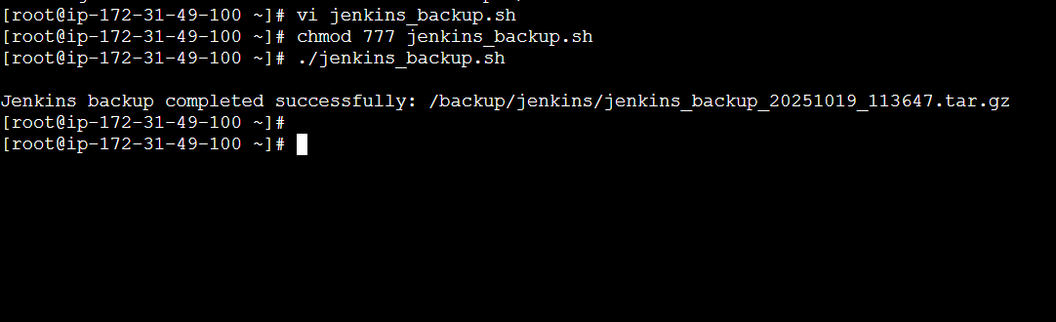
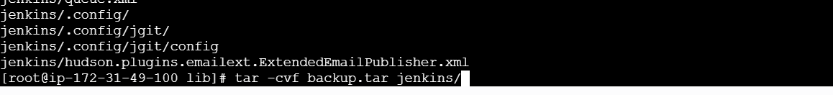
5.Take backup of Jenkins using thin backup plugin
Go to manage Jenkinsclick on pluginssearch thin backup plugin install.
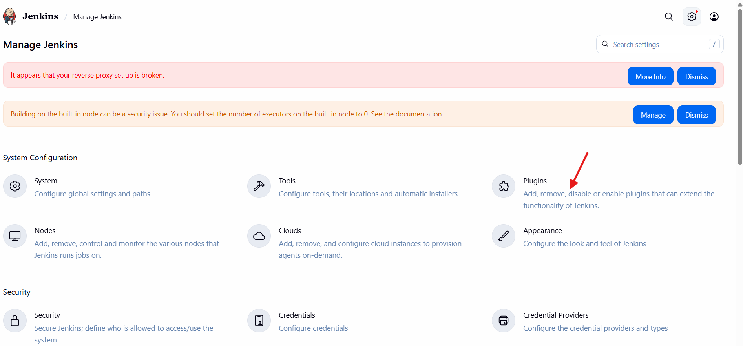
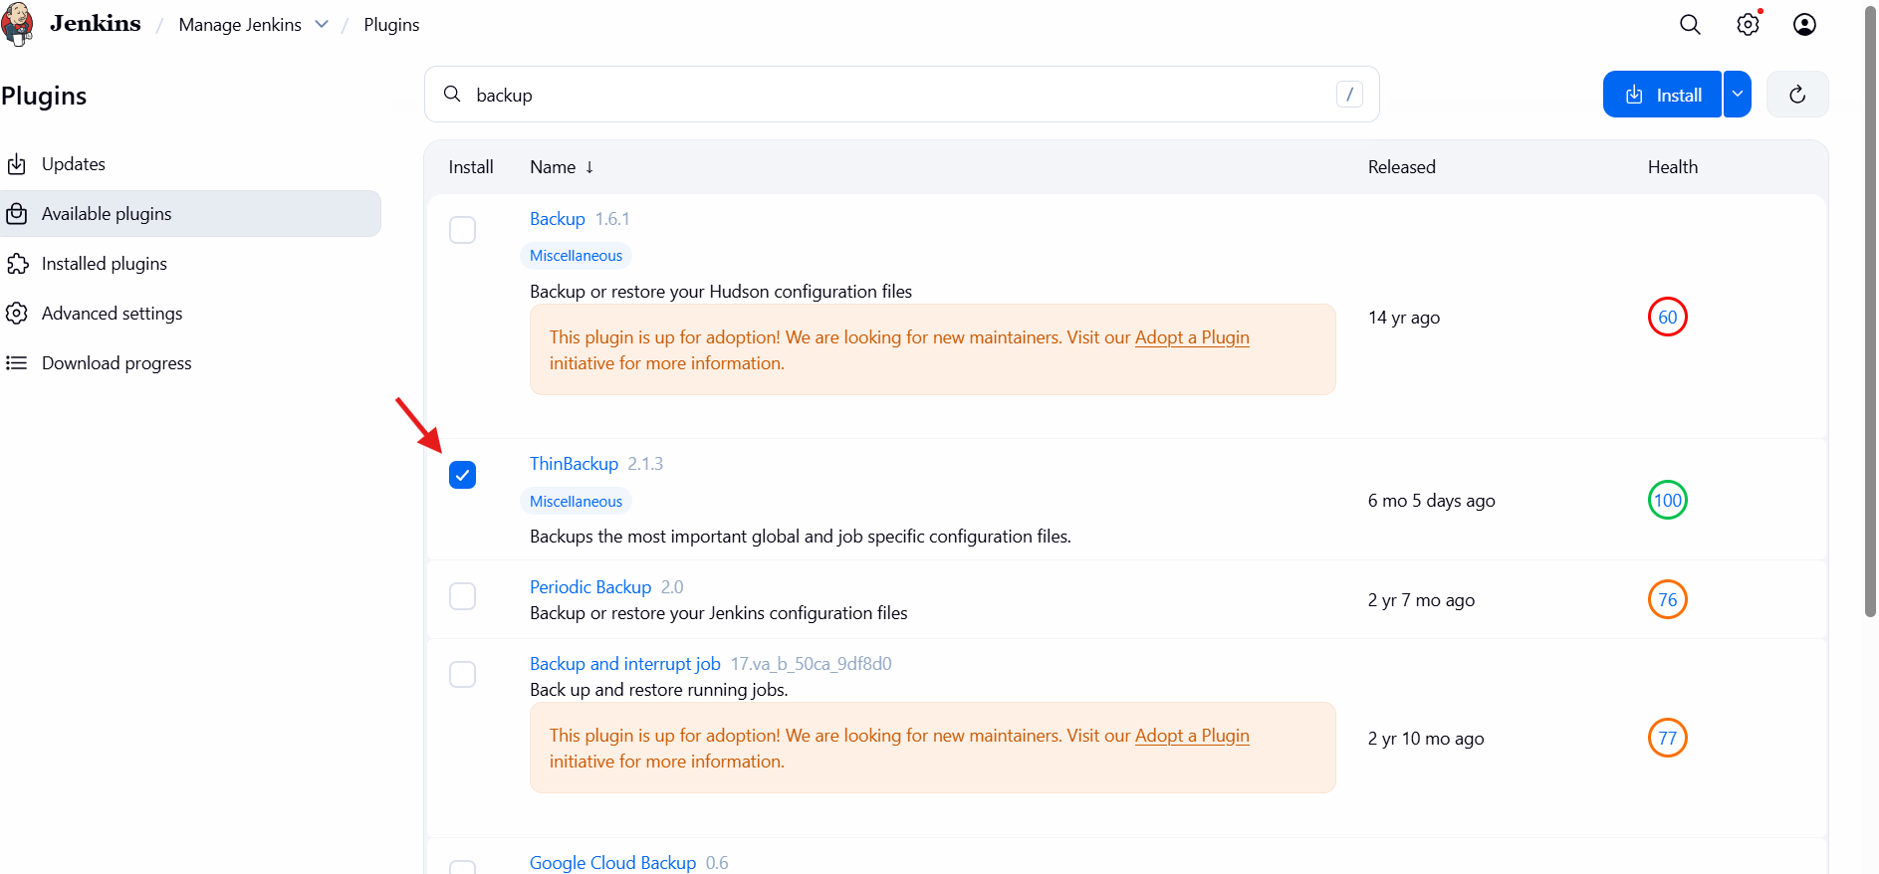
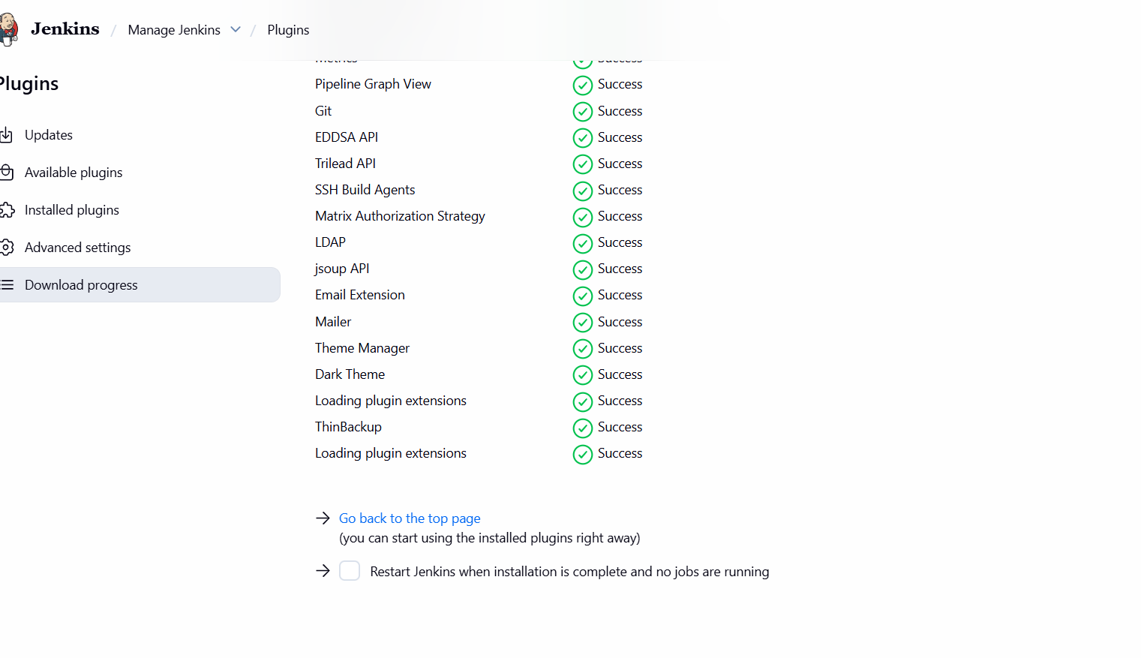
After it was successfully installed we can see the plugin in the tools and actions.
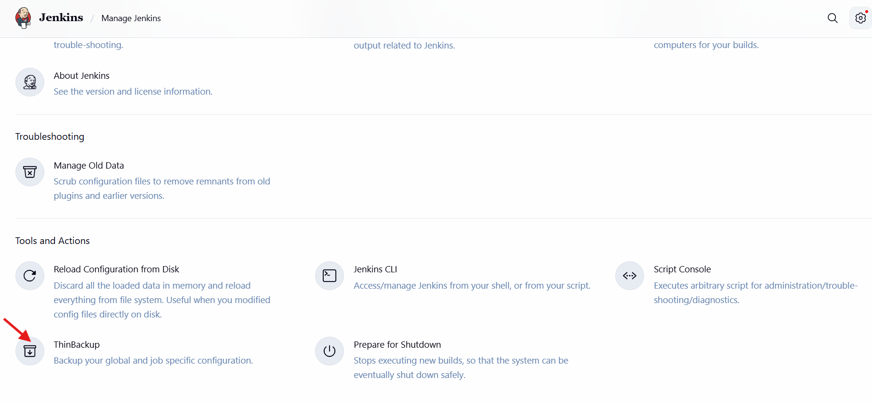
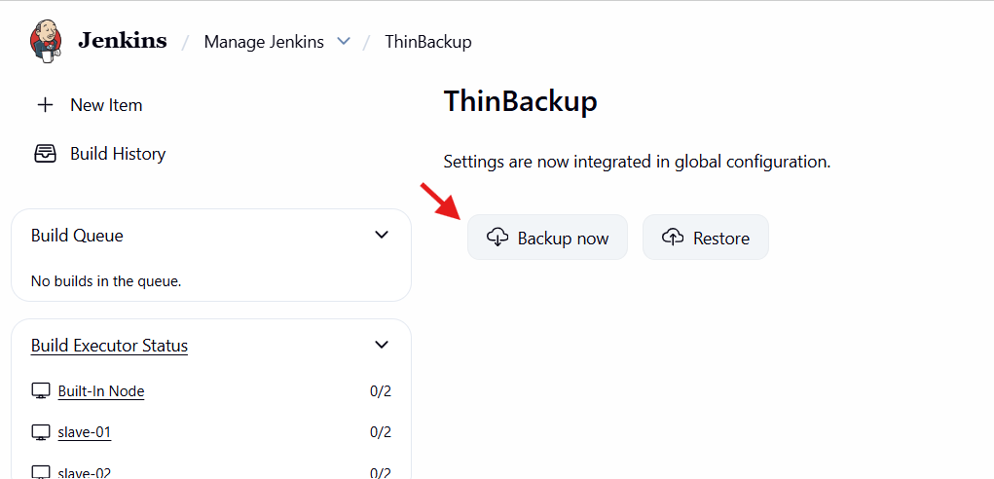
6.Setup a new Jenkins server and dump the backup taken in task4.
Step-1 :create a new Jenkins server.
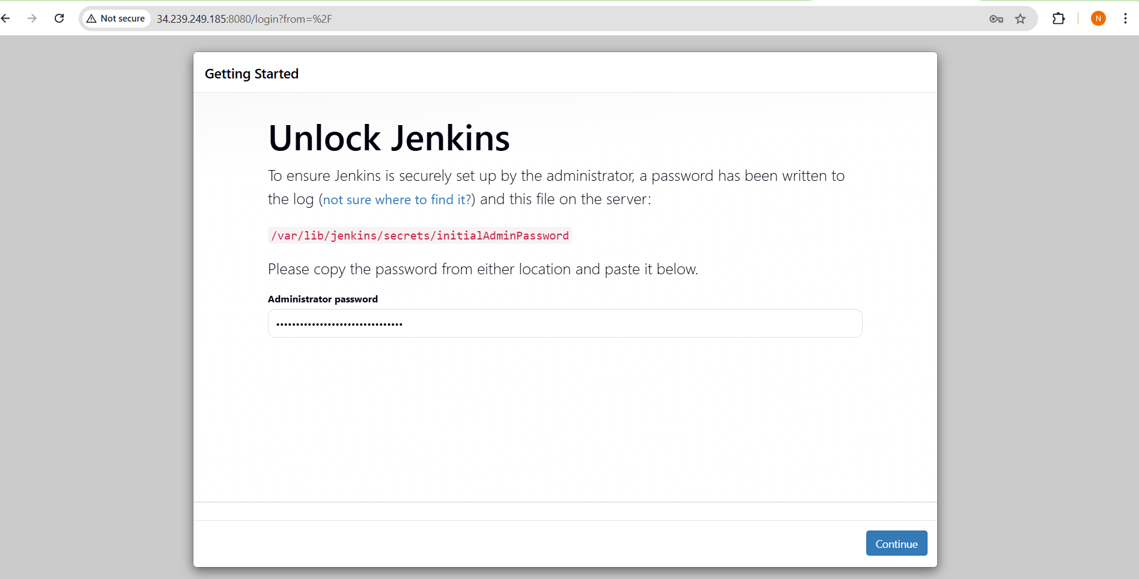
Step-2: Go to /var/lib/
We can find the backup.tar taken in task4.
Copy the pem key and and give the chmod 600 permission.
Run this command:scp -I pem key backup.tar username@ip address:/tmp/

